**Lab 2: Hello World Application**

# **Introduction**

In this Exercise, we will create a straightforward programme that prints a straightforward string of text called "Hello World" on the screen.

This exercise's goal is to familiarise participants with the Android studio environment.

**Let’s get Started**

**Step 1: Create a New Project in Android Studio as shown below**

**Step 2: Select Empty Activity as shown below**

**Step 3: Provide a Project Name as shown below**

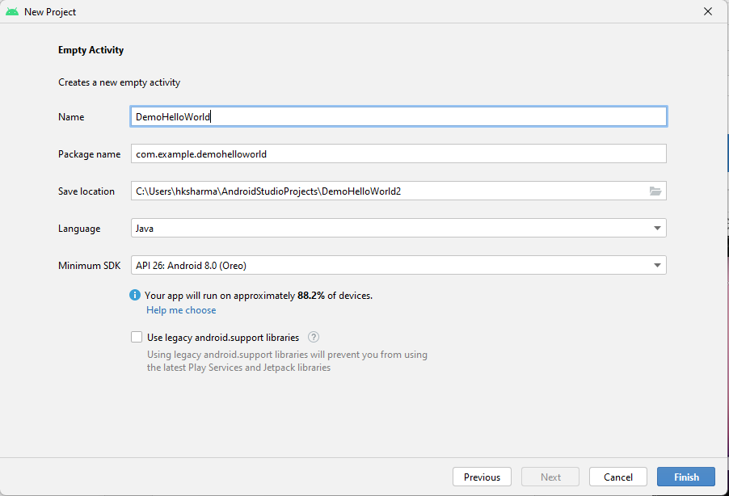

**Step 4: Update MainActivity.java as per the code given below**

**package** com.example.demohelloworld;  
  
**import** androidx.appcompat.app.AppCompatActivity;  
  
**import** android.os.Bundle;  
  
**public class** MainActivity **extends** AppCompatActivity {  
  
 @Override  
 **protected void** onCreate(Bundle savedInstanceState) {  
 **super**.onCreate(savedInstanceState);  
 setContentView(R.layout.***activity_main***);  
 }  
}

**Step 5: Update activity_main.xml for Vertical Orientation as per the code given below**

*<?***xml version="1.0" encoding="utf-8"***?>*<**androidx.constraintlayout.widget.ConstraintLayout xmlns:android="http://schemas.android.com/apk/res/android"  
 xmlns:app="http://schemas.android.com/apk/res-auto"  
 xmlns:tools="http://schemas.android.com/tools"  
 android:layout_width="match_parent"  
 android:layout_height="match_parent"  
 tools:context=".MainActivity"**>  
  
 <**TextView  
 android:layout_width="wrap_content"  
 android:layout_height="wrap_content"  
 android:text="Hello World!"  
 app:layout_constraintBottom_toBottomOf="parent"  
 app:layout_constraintEnd_toEndOf="parent"  
 app:layout_constraintStart_toStartOf="parent"  
 app:layout_constraintTop_toTopOf="parent"** />  
  
</**androidx.constraintlayout.widget.ConstraintLayout**>

**Step 6: Check Output on Android Emulator and it should look like as given below**

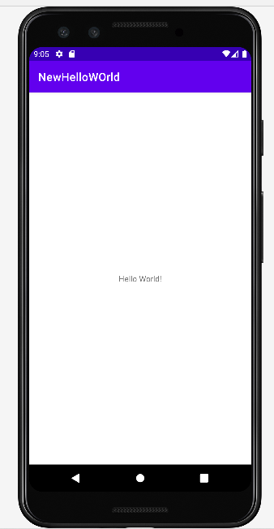

**Voila!!** We have successfully completed this lab.